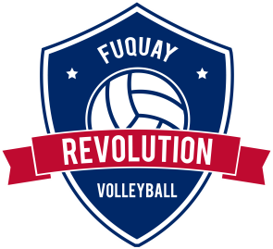
Waiver and Release of Liability Form
USAV – Fuquay Revolution Volleyball
Note: This form must be read and signed before the participant is allowed to take part in any Fuquay Revolution Volleyball training, competition, meeting, or testing sessions. By signing this form, the participant affirms having read it.

Participant Name: _____________________________________________________________

Sponsoring Organizations: USA Volleyball, Fuquay Revolution Volleyball, and their officers, administrators, official agents, employees and/or coaches, staff and other representatives of the above mentioned organizations. In consideration of my involvement under the auspices of this sponsoring organization, I acknowledge and agree that:
1. I risk bodily injury, including paralysis, dismemberment, and death as well as loss of or damage to property;
2. I knowingly and freely assume all such risk; and
3. I for myself, and on behalf of my heirs, assigns and next of kin, hereby release from liability and hold harmless the following entities: USA Volleyball, Fuquay Revolution Volleyball and their officers, administrators, official agents, employees and/or coaches, staff and other representatives of the above mentioned organizations with respect to any and all such injury, paralysis, dismemberment, death, and/or loss of or damage to property except which is the result of gross negligence and/or willful or wanton executed this waiver freely, voluntarily and understandingly.

This is to certify that I, as a parent/guardian of this participant, do consent to his/her release of USA Volleyball, Fuquay Revolution Volleyball, and their officers, administrators, official agents, employees and/or coaches, staff and other representatives of the above mentioned organizations for any and all liabilities incident to his/her involvement in the programs conducted by USA Volleyball and its Regional Volleyball Associations. We have read the above Waiver and Release, understand that we have given up substantial rights by signing it and sign it voluntarily.

__________________________________________________ ____________________
Participant’s Signature Date

__________________________________________________ ____________________
Parent/Guardian Name/Relationship (Signed) Date

__________________________________________________
Parent/Guardian Signature (Print)

__________________________________________________ ________________________ Emergency Contact E-mail Address

